Case Study
by Dr. Mortada Abozaid

A female patient, 43 year old came to the outpatient clinic of Sohag university hospital complaining of diminution of vision in both eyes for 7 years. She has no history of diabetes mellitus nor systemic hypertension but she has been treated for 10 years of rheumatoid arthritis. On examination, her visual acuity was 5/60 in both eyes and the intraocular pressure was 15 mmHg in both eyes. The anterior segments of both eyes looked more or less normal on slit-lamp examination. The fundus photography is shown in figure-1. While the fluorescein angiography and OCT images are shown in figures 2 and 3 respectively.

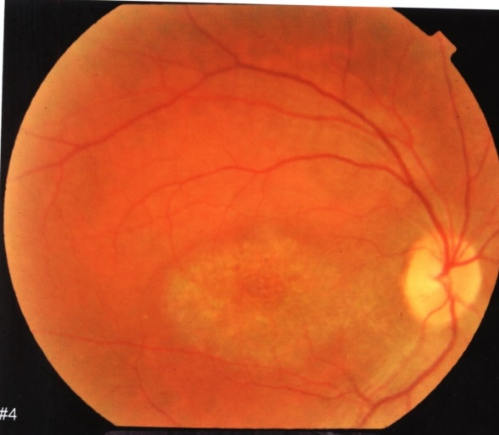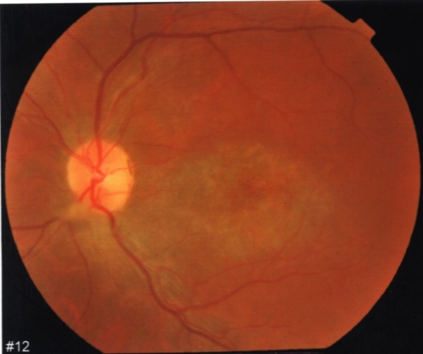
Figure-1. Fundus appearance of both eyes.
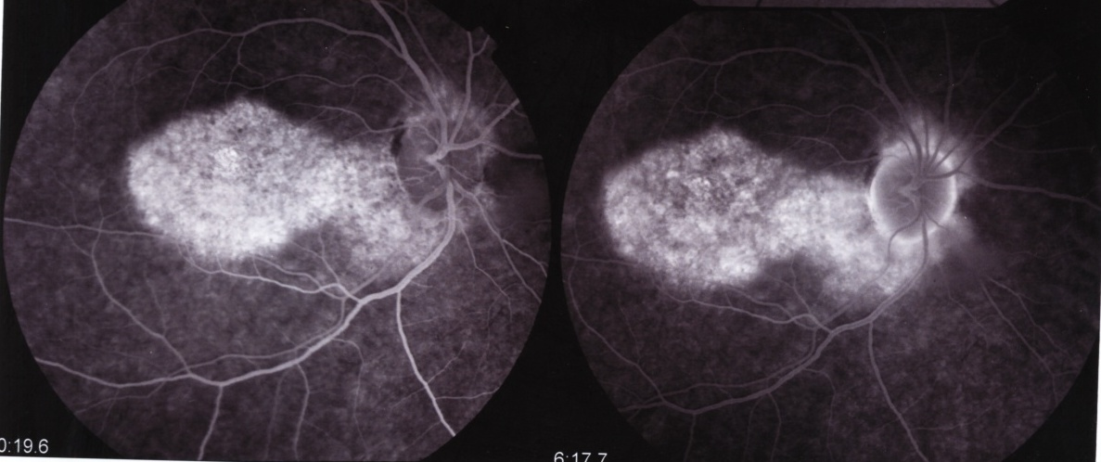

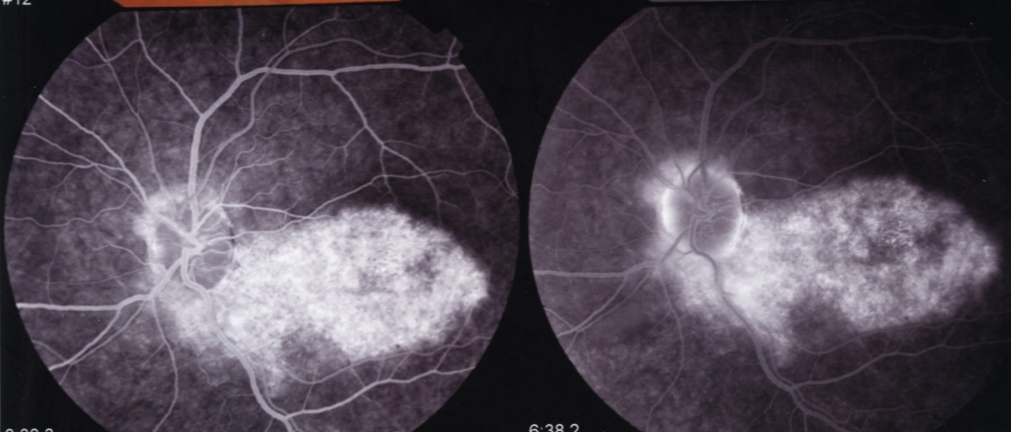
Figure-2. FA (early and late phases) of both eyes.
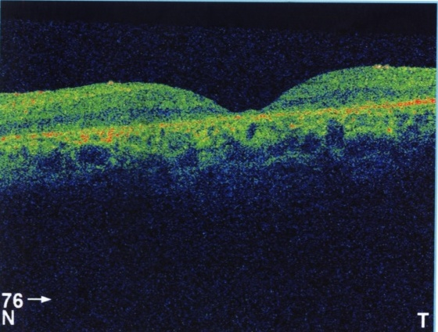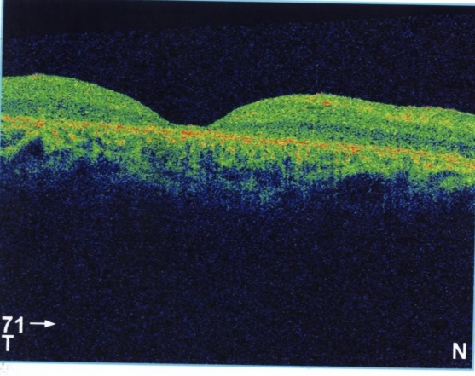
Figure-3. OCT appearance of the macula in both eyes.

Questions:
- What is the differential diagnosis of this case?
- What is the most likely diagnosis?
- How can we treat this patient?

with my best wishes
Dr. Mortada Abozaid

